**Add Two Numbers Using Input Box**

**Private Sub Command1_Click()**

**Dim A As Integer**

**Dim B As Integer**

**Private Sub form_load()**

**A = InputBox("Enter Value of A")**

**B = InputBox("Enter Value of B")**

**MsgBox "Sum=" & Val(A) + Val(B)**

**End Sub**

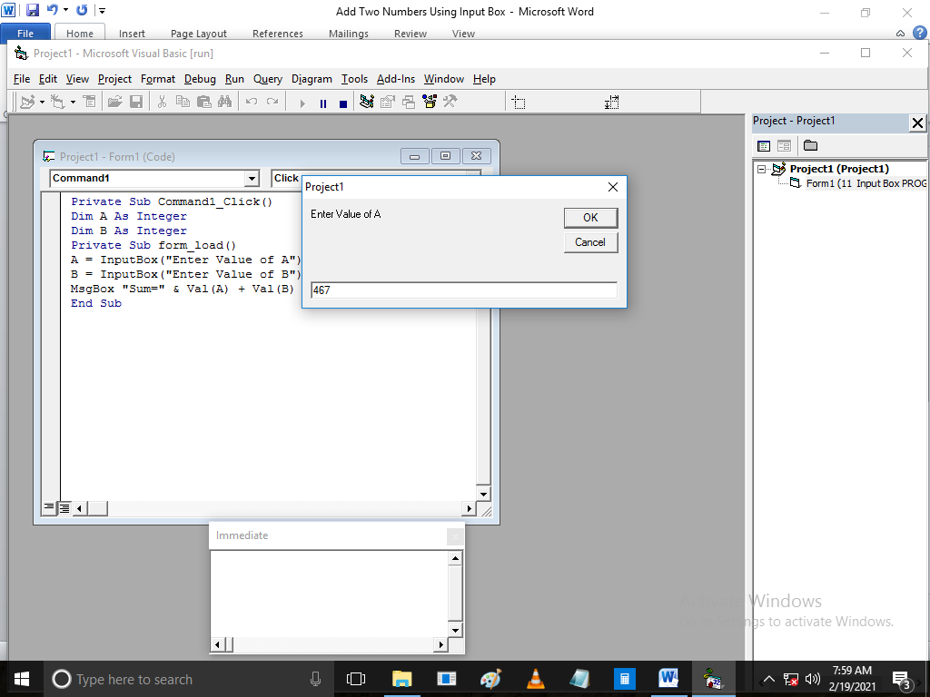

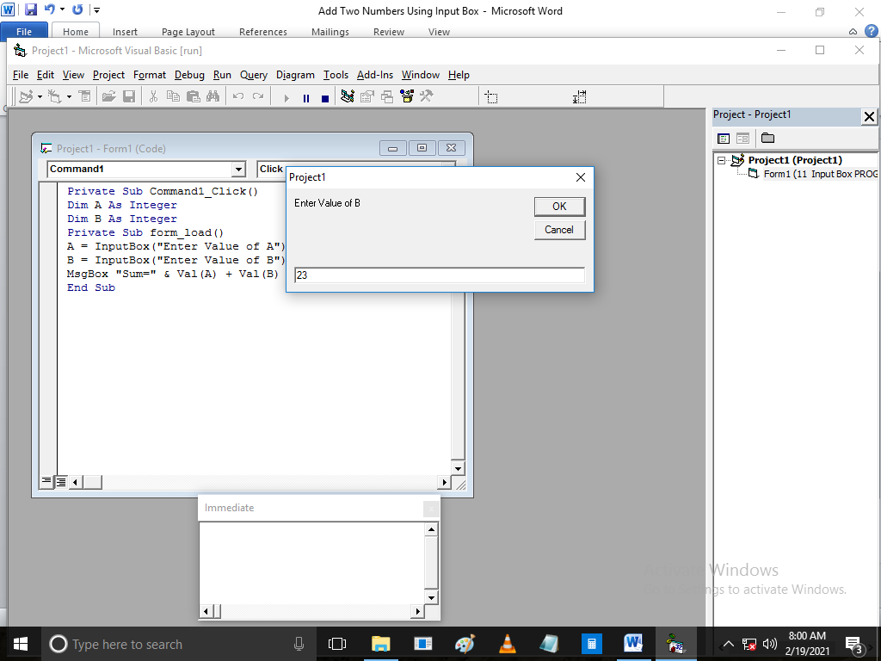

**Result**

